Ben Sottile

Hands on Project 3.3

1. 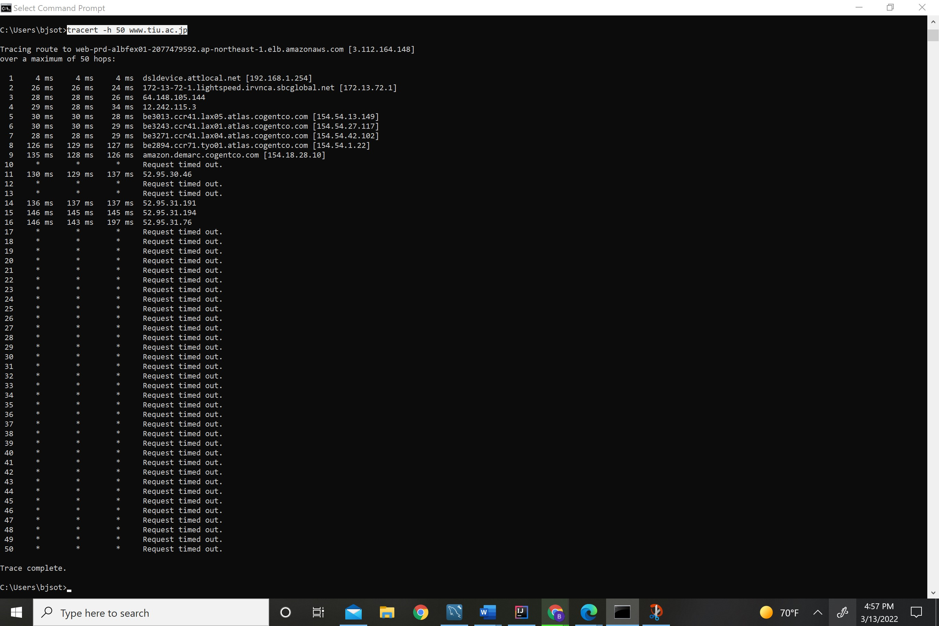

Command Used: Tracert -h 50 [www.tiu.ac.jo](http://www.tiu.ac.jo)

1. The hop to Japan happens from 7->8 127/29*100= roughly 437%
2. 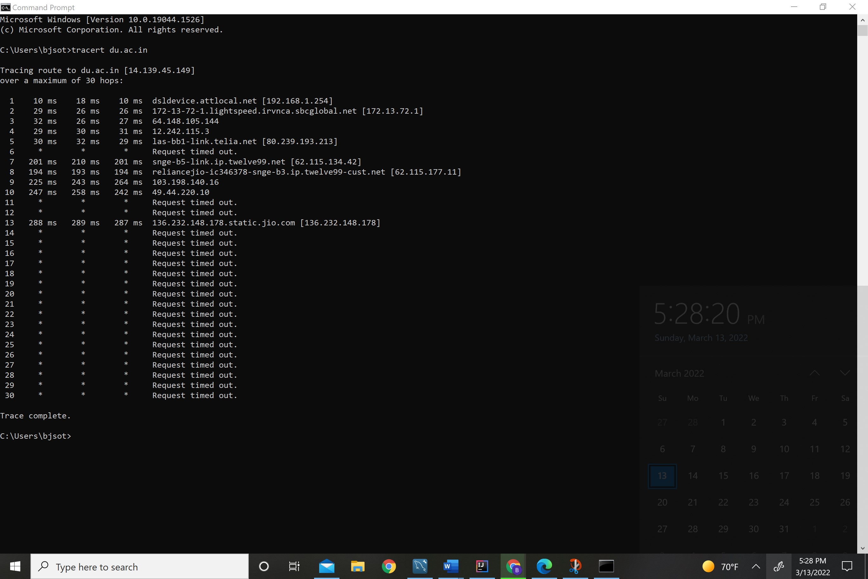

Jump is from 4,5 which is weid because the speed REALLY drops of between 5 and 7.

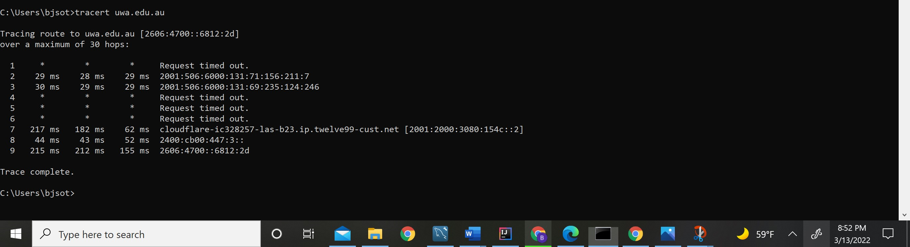

5.

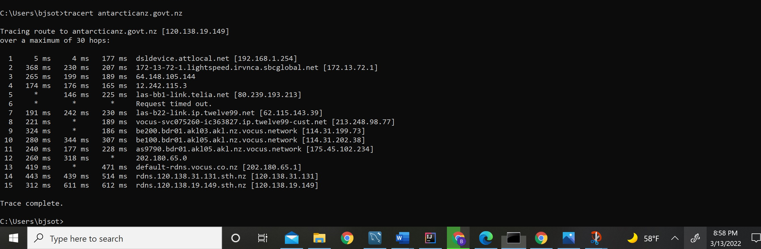

New Zealand

1. <https://www.kreml.ru/>

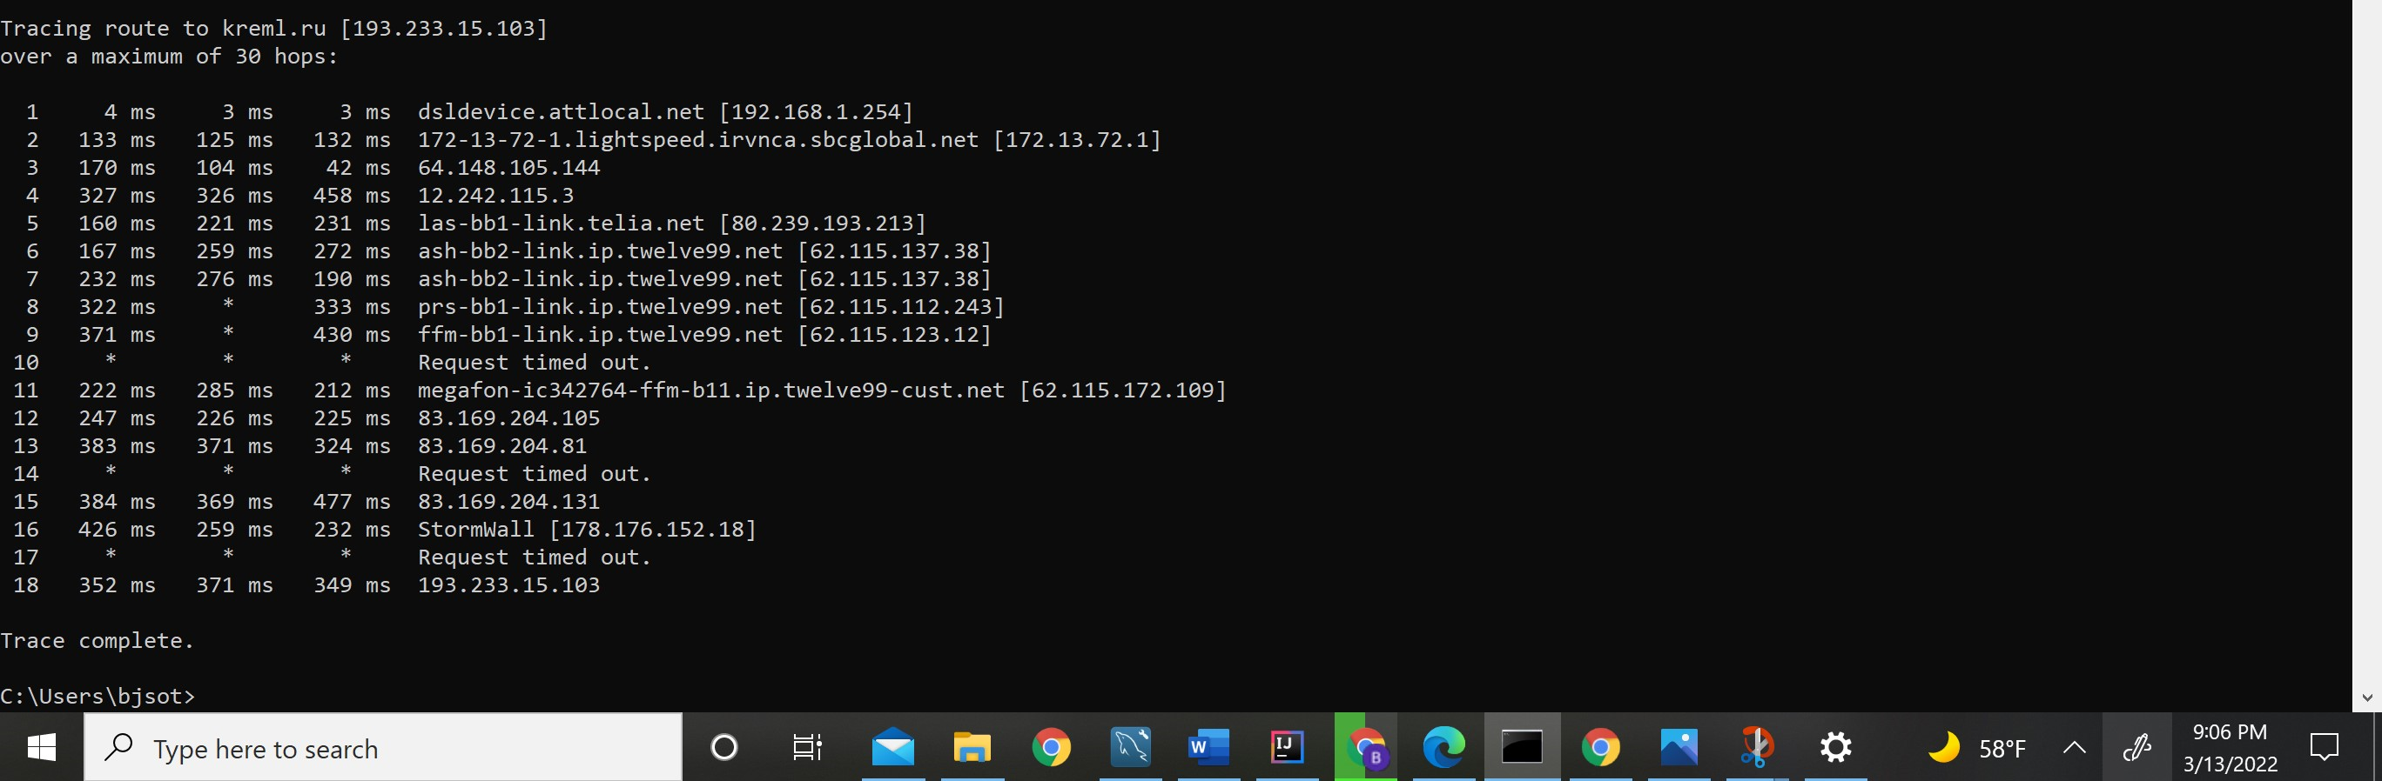

7.

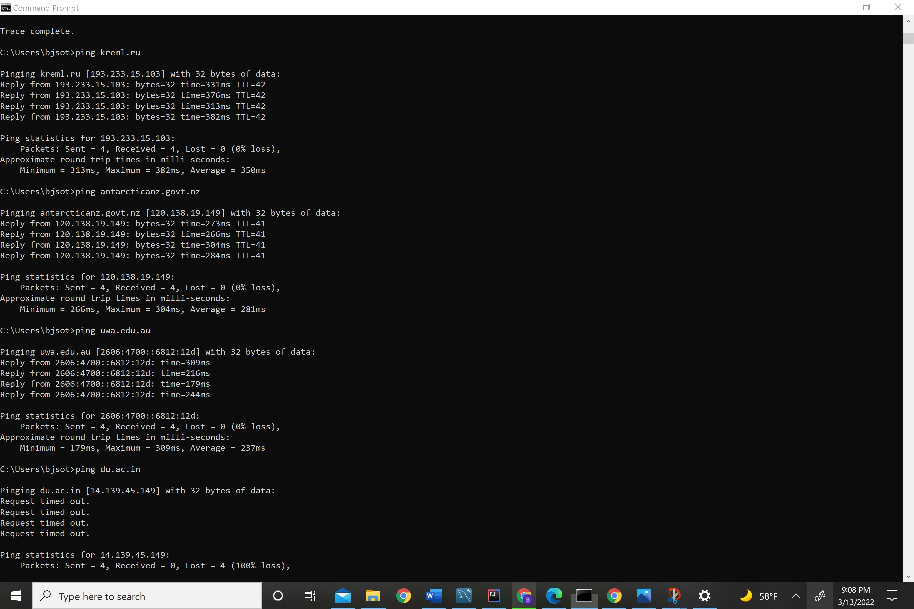

Hands on project 3.4

File Sharing on network wasn’t working

Throughput test

